2021 – 2022
Bemiss Elementary
School Supply List

General classroom supplies such as pencils, glue, crayons, scissors, markers and tissue are provided by the school district.
The following are recommended for students to bring to school.
*Supply quantities requested for
Bemiss students only

Kindergarten – Grade 2
Gym shoes for Fitness & Health
Backpack with student name clearly printed inside

Grade 3
2 1” 3-ring binder*
2 Composition notebook *
3 Spiral notebooks, 8.5”x11”, 70-sheet * (wide-ruled)
1 package 8-pack Crayola markers
Gym shoes for Fitness & Health
Backpack with student name clearly printed inside

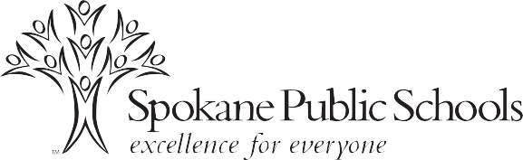

Grade 4
1 1” 3-ring binder *
4 Notebook paper – Wide Ruled *
1 Composition notebook *
3 Portfolio folders with pockets, 3-hole *
3 Spiral Notebooks (red, blue and green)*
1 package subject dividers for 3-ring binder
Pencil/supply pouch to place inside 3-ring binder
1 package 8-12 colored pencils
Gym shoes for Fitness & Health
Backpack with student name clearly printed inside

Grades 5 & 6
1 1” 3-ring binder *
4 Notebook paper – College Ruled *
1 Composition notebook *
5 Portfolio folders with pockets, 3-hole *
5 Spiral notebooks, 8.5”x11”, 70-sheet *
3 Pens * (black, red, blue)
4 Highlighters * (different colors)
1 package subject dividers for 3-ring binder
Pencil/supply pouch to place inside 3-ring binder
12-inch ruler with centimeters and inches
1 package 8-12 colored pencils
Gym shoes for Fitness & Health
Backpack with student name clearly printed inside

